**How to Add the Parent Calendar to your site.**

1. Go to the campus webpage: nisd.net/Henderson

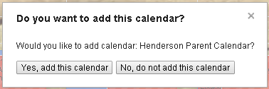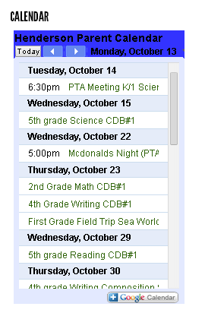

2. On the Main Page in the right sidebar, Click on the “Google Calendar” icon.

3. If you are already logged in to Gmail you will get a pop-up asking if you want to add the calendar. Click “Yes, add this calendar”.

The calendar will now be added to your list of calendars. Make sure it is selected.

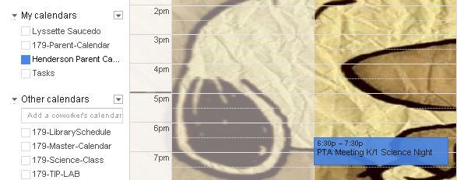

Sample Event

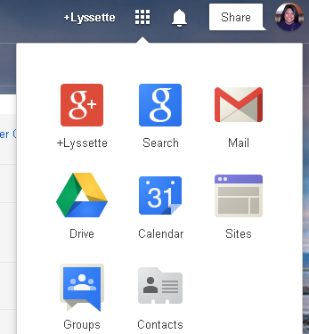

4. Go to your Google Site. From your Gmail, click the “Apps Icon” then click on “Sites”.



5. Click on Your Google Site Link. 6. On your site page, click on the “Edit” button and place your cursor in the section of your page you want your calendar to appear.

7. In the edit ribbon Click on “Insert” then click on “Calendar”.

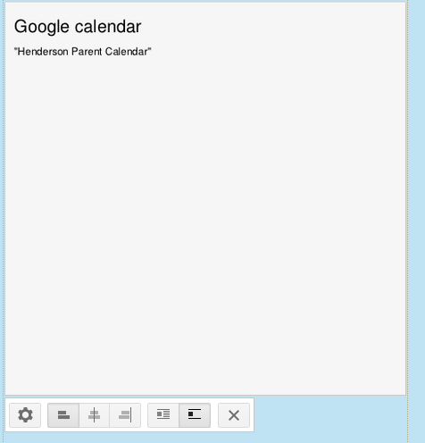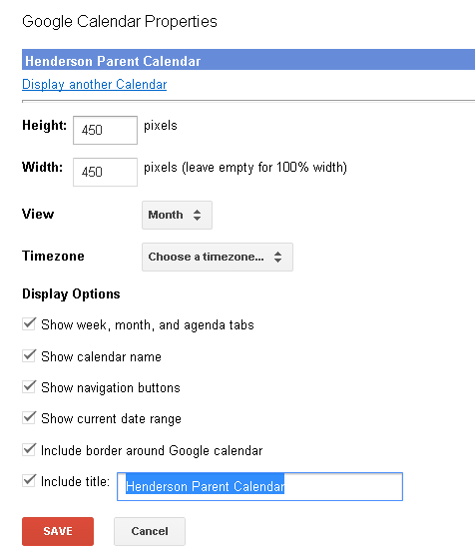 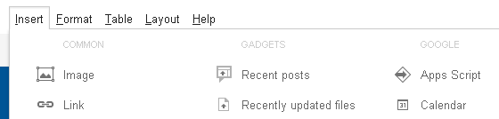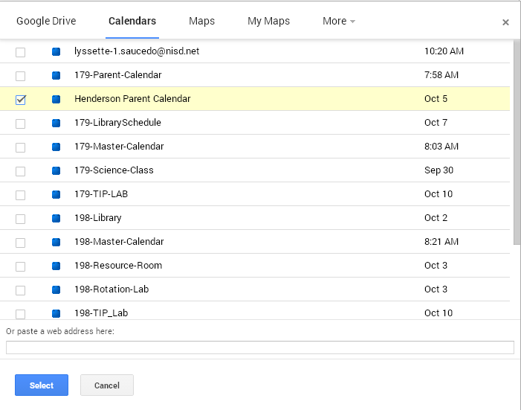

*If there’s other existing calendars you want to add. Repeat steps 6 – 9 for each calendar.

8. A list of your calendars will pop-up. Place a Checkmark next to the “Henderson Parent Calendar” and click “Select”.

9. Adjust your calendar settings as needed. Click “Save” once done.

I like 450x450 pixels.

*Play with the options and change based on your preference.

*To make additional changes after you have added the calendar. You MUST be in Edit mode. Click on the calendar widget on your page to get the settings icon. Click on the “Settings” icon and make the changes.