Share your Google Site
Click on the “Share” button
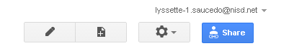
In the sharing page:
Link to share: This is the link to your site.
Click on the “Change” link under who has access.
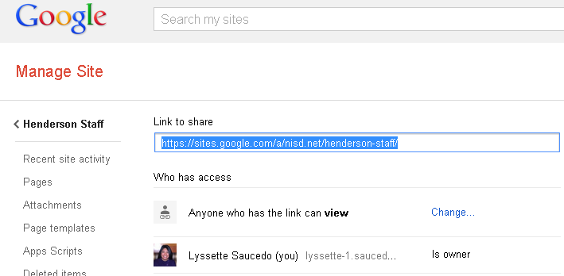
Ensure “Anyone with the link” is selected. Ensure the access level is set to “View”. Click “Save”. Next copy the link to your site and send it to lyssette-1.saucedo@nisd.net

