**Google Sites Editing Cheat Sheet**

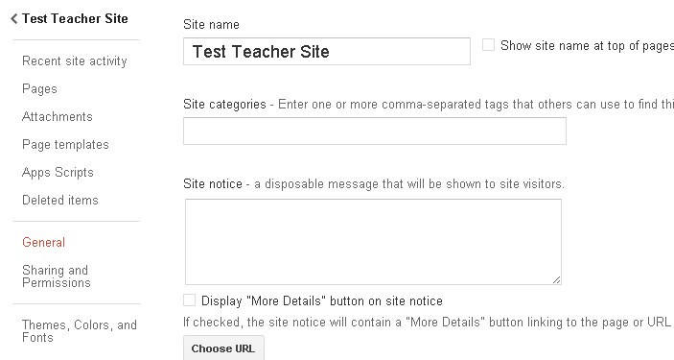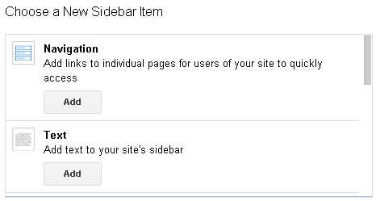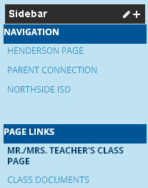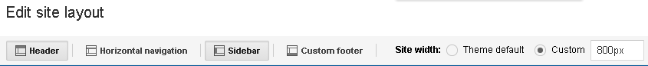

**Editing Ribbon: Insert lets you add pics, calendars, widgets, etc.**

**<HTML> will let you insert copied code into your site (i.e.Remind)**

**“+”: Add more Sections to Your Sidebar**

**Layout Editing Ribbon**

**Sidebar Editing Pane: Click within the Sidebar Section to Edit that Section**

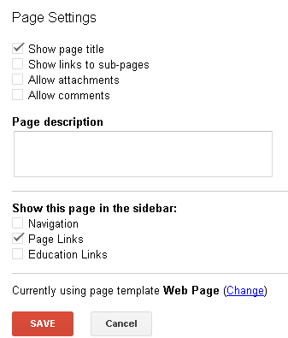



**Edit Body Content**

**Share Your Site**

**Advanced Editing**

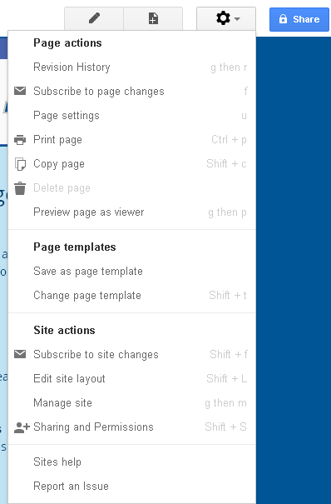

**See what Your Parents will see**

**Advanced Site Options**

**Contact Me if you need Help.**

