Google Calendar Daily Agenda
Move over Siri & Cortana, Google Calendar can send your daily agenda daily @ 5AM!
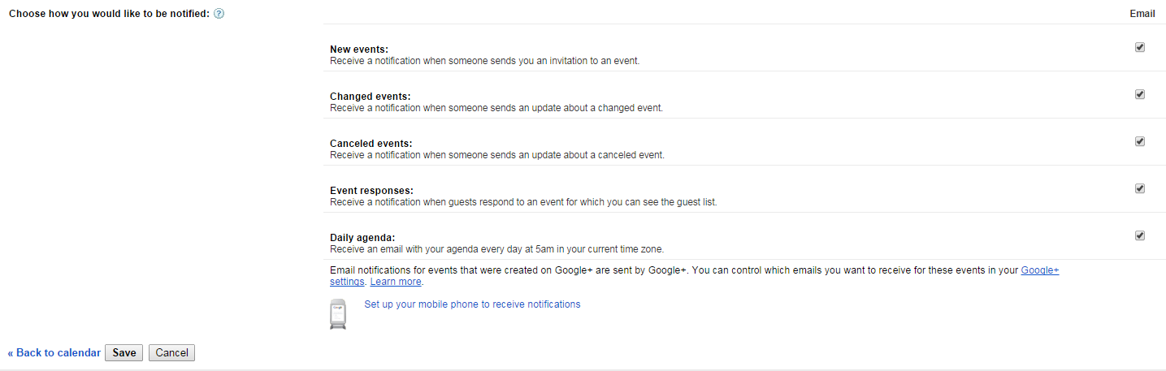
Check the box next to “Daily Agenda” and click on “Save”.
Click on “Calendars”. Under the NOTIFICATION, click on “Reminders and notifications” next to the calendar you want to receive an agenda from.
From Your calendar view click on the “Settings” gear

